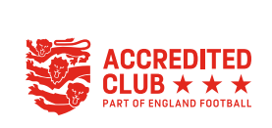
Founded: 1990
WEST BRIDGFORD COLTS FOOTBALL CLUB
AGM meeting Minutes – Thursday 12th October 2023 @ 8pm, 1862 Suite Notts County

Attendees: 89

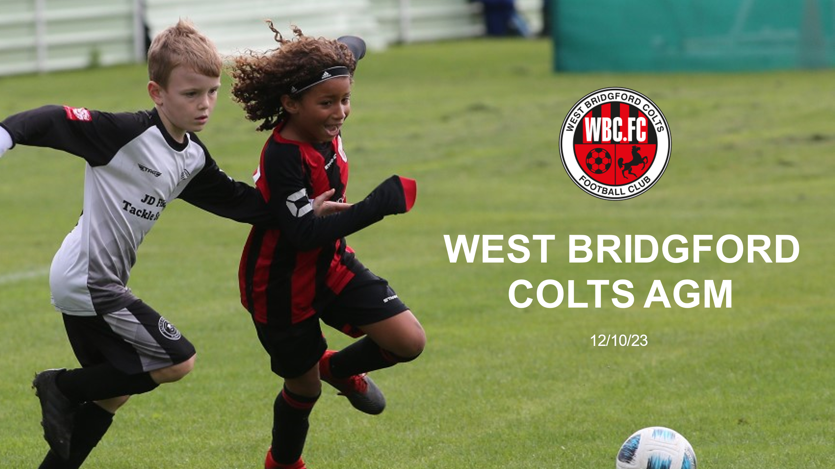

Agenda
- Election of trustees
- Treasurer’s report
- Chairman’s report
- Q & A
- Guest Speaker – Richard Whitehead

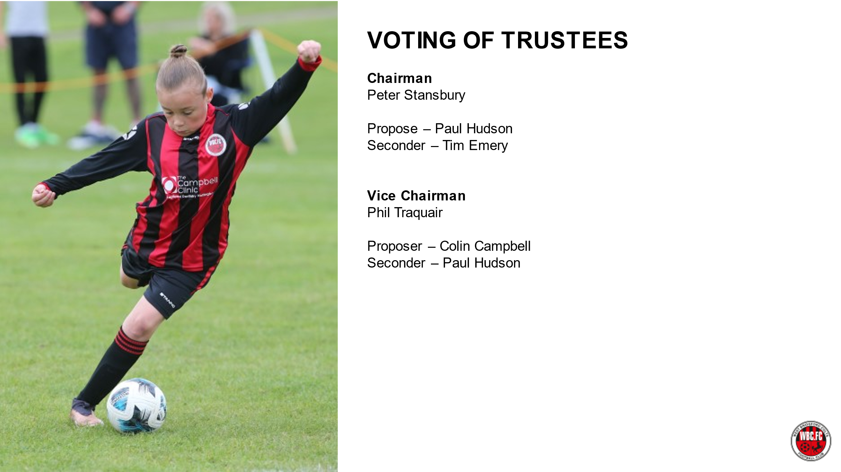


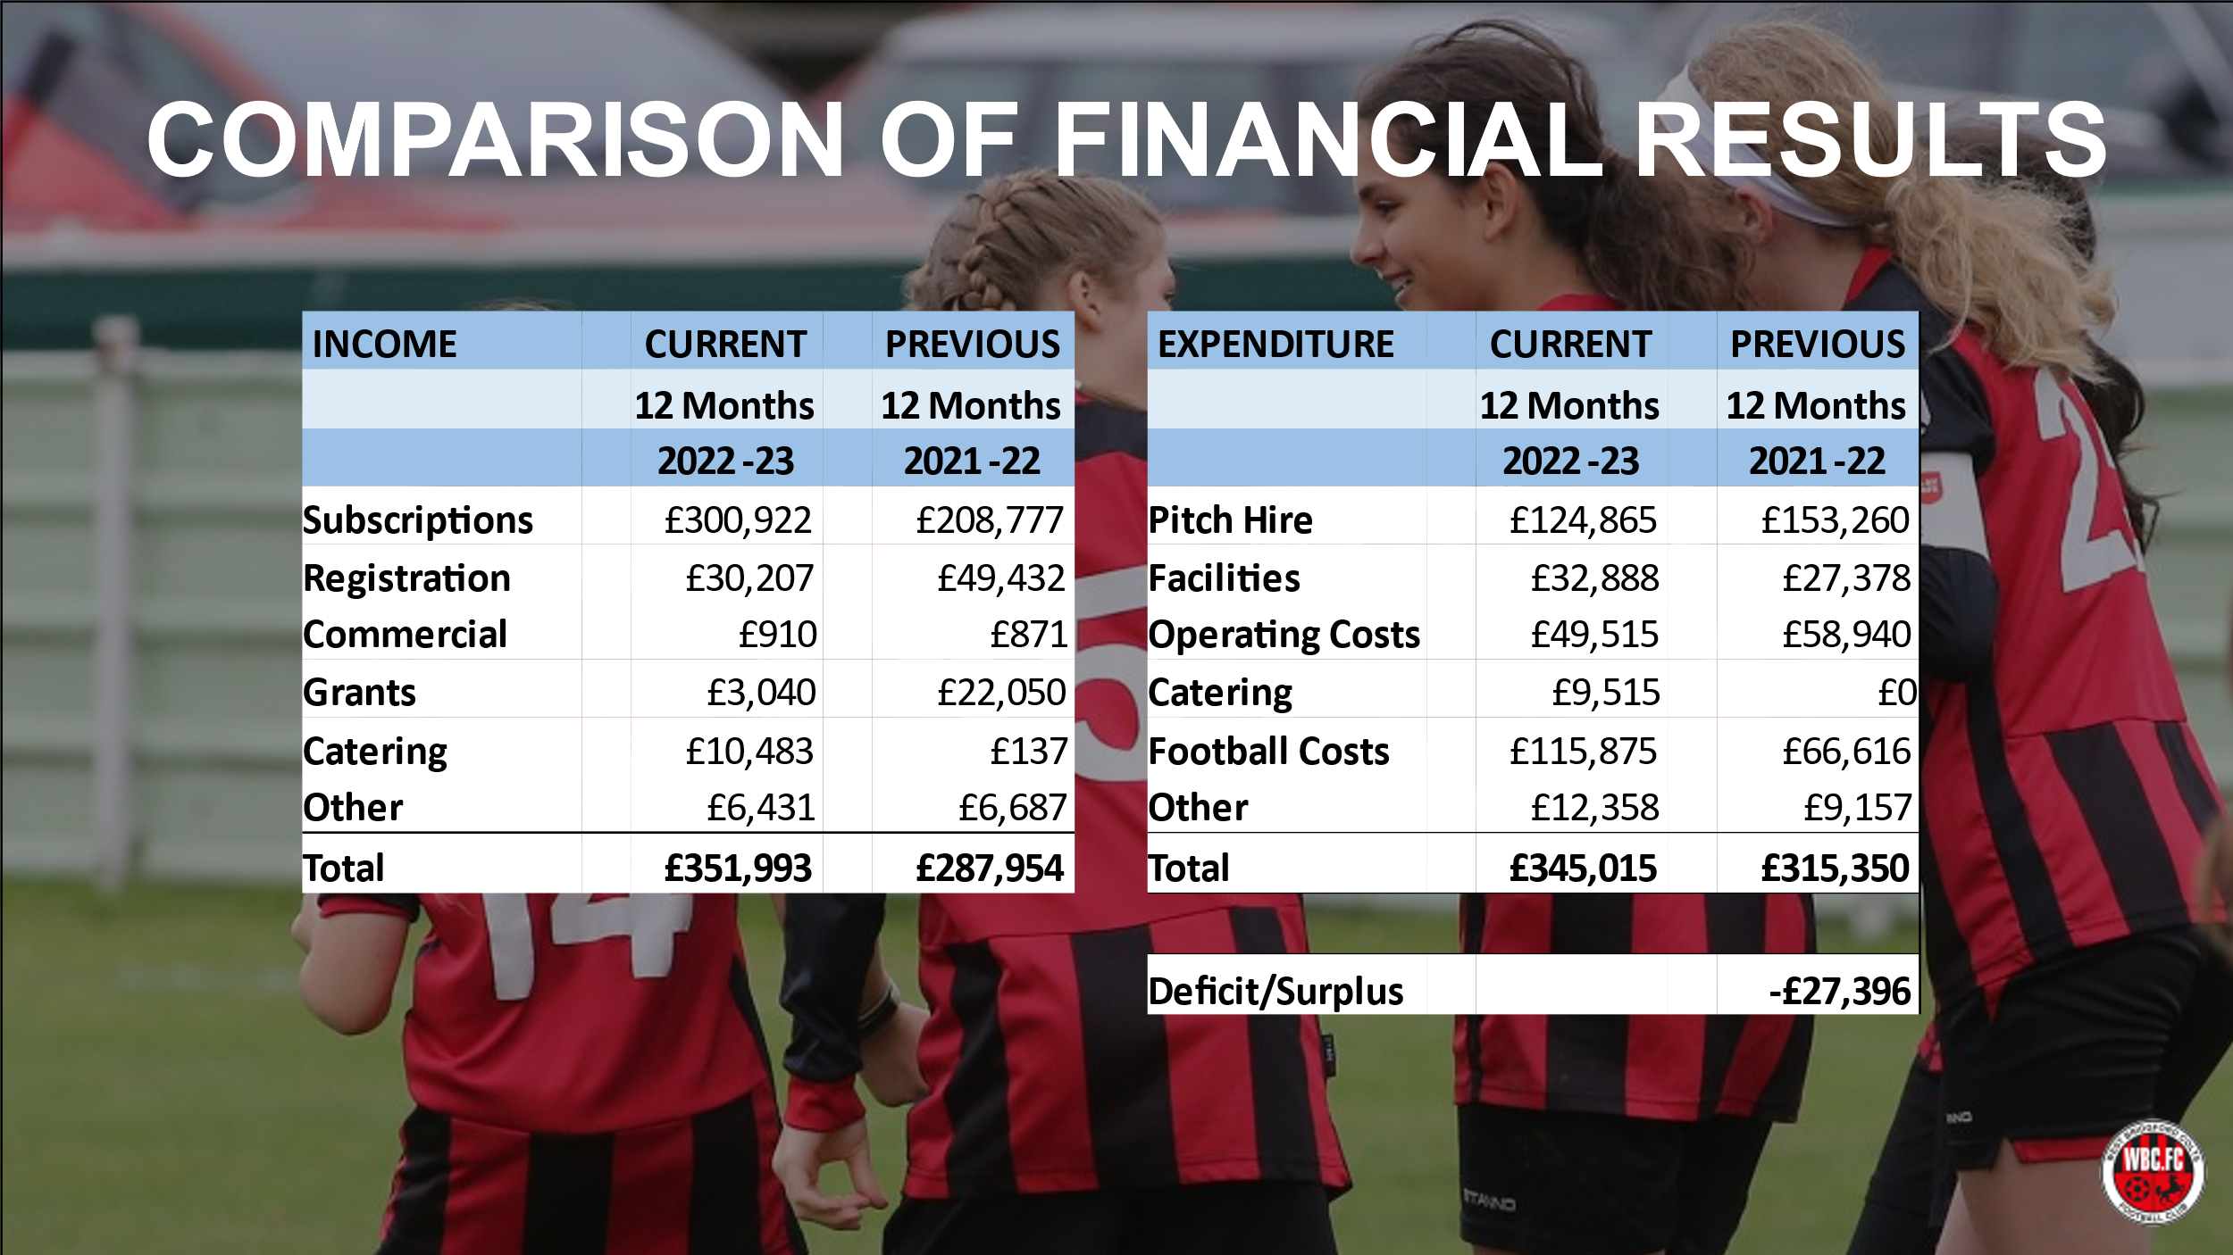
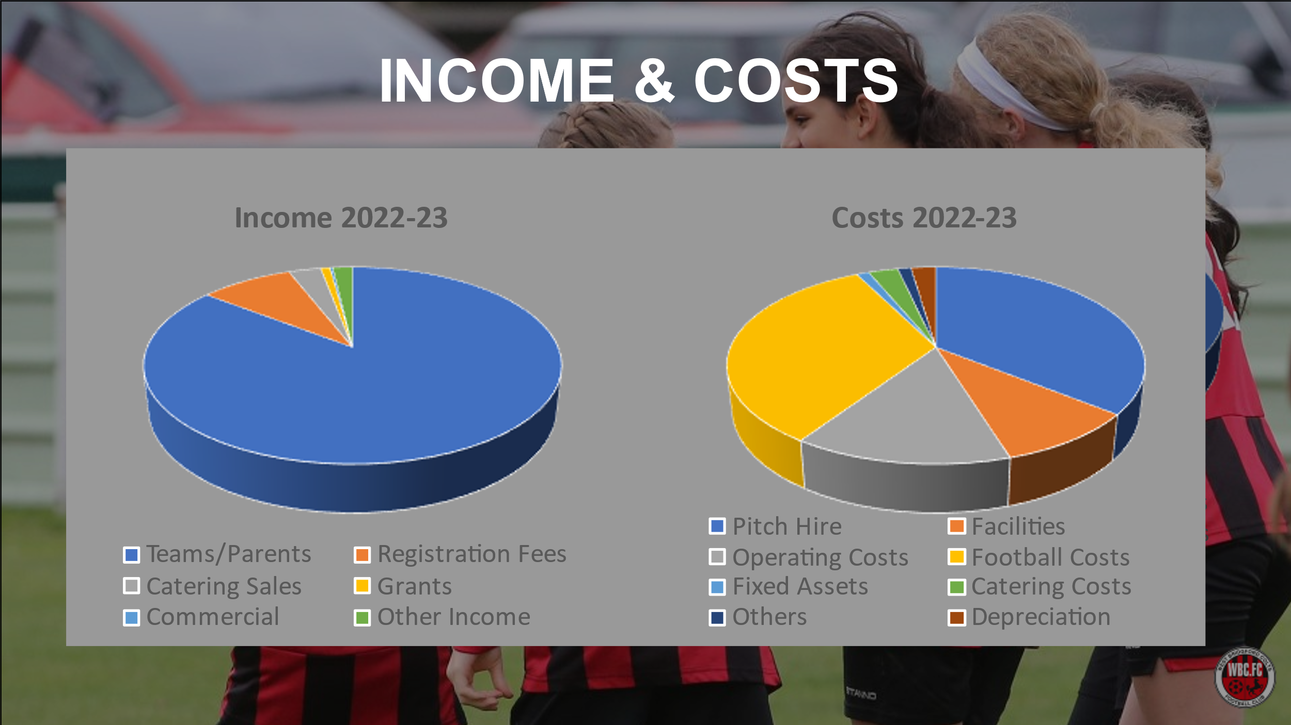
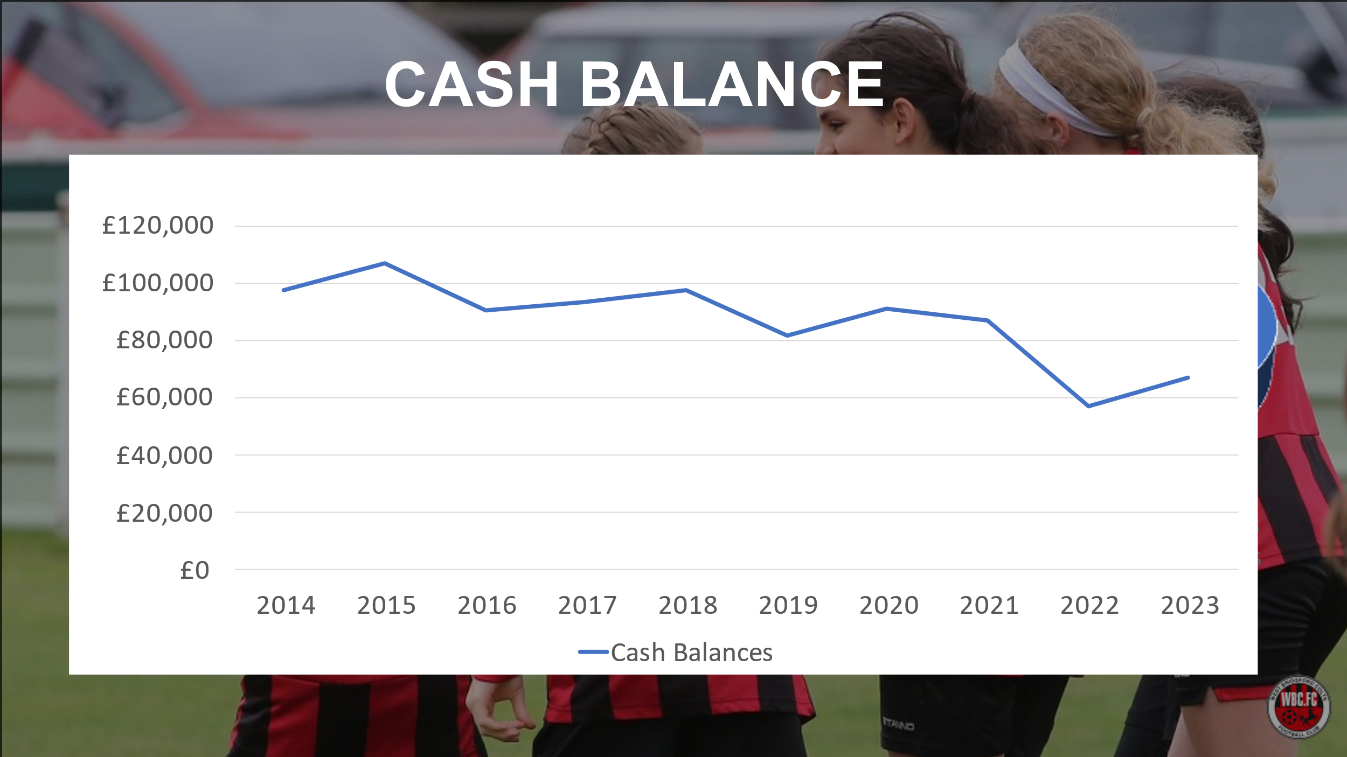
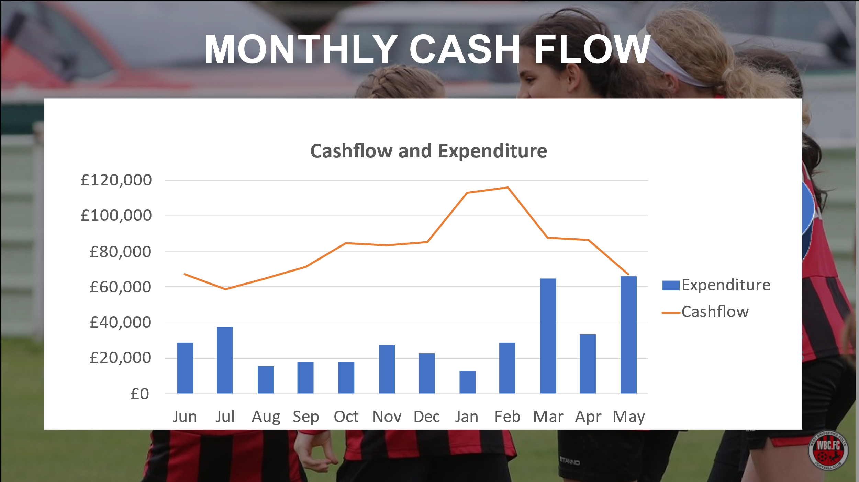
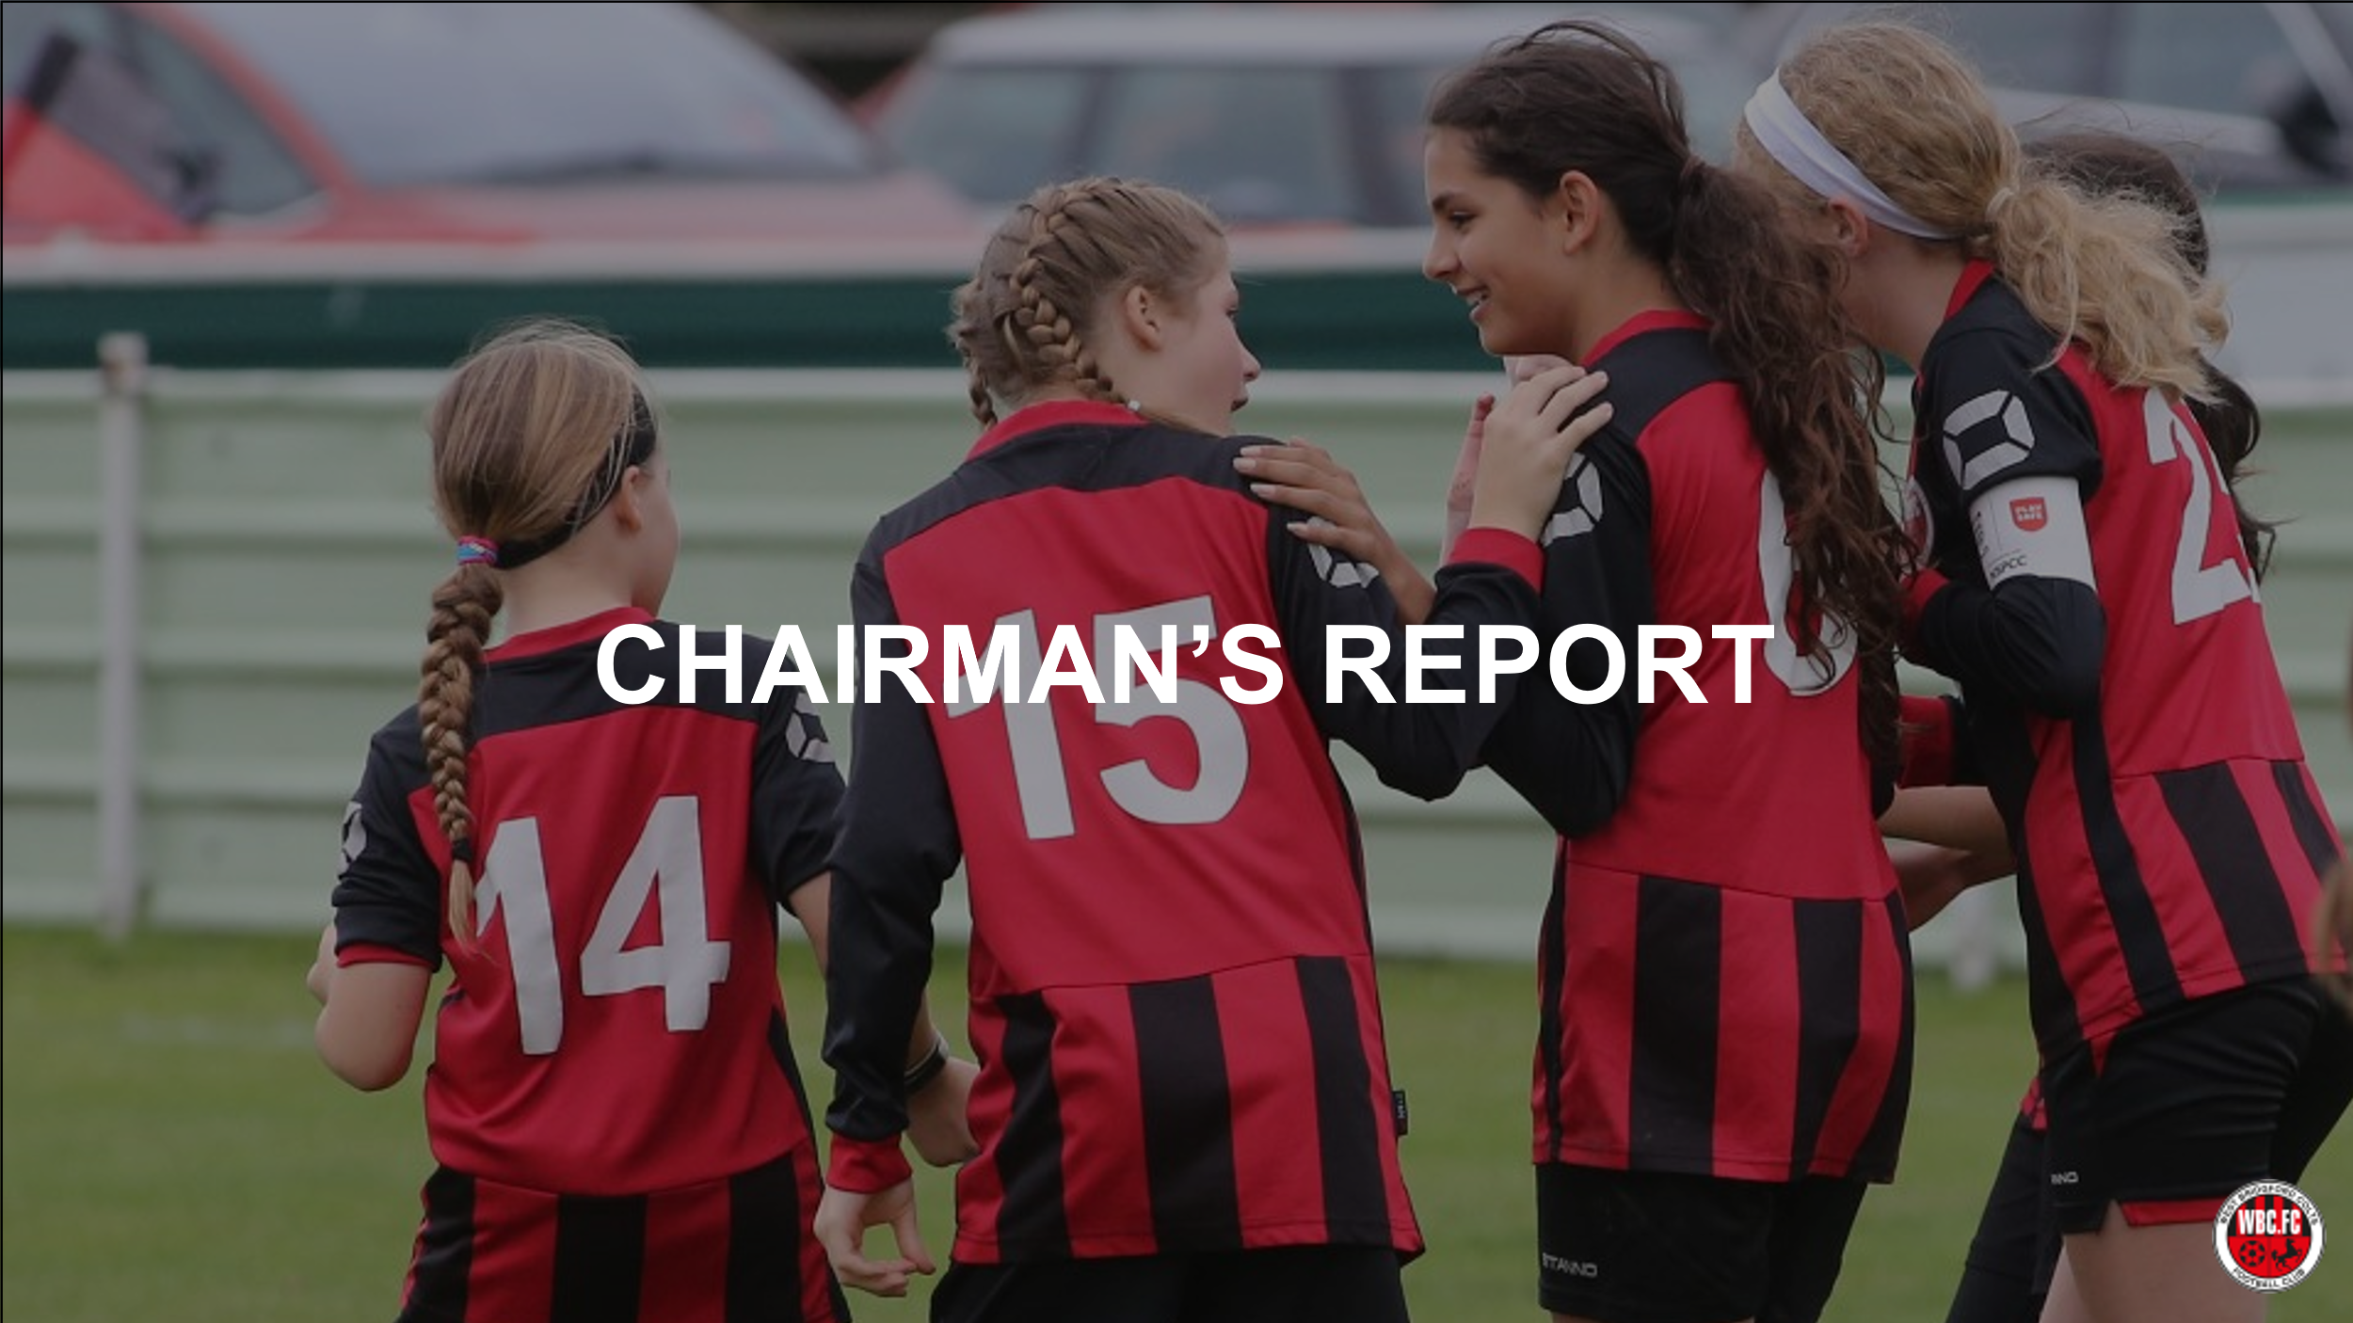
- Condolences to the family and friends of Tom Hamilton-Dick U11 Blackhawks team coach who died suddenly 2 weeks ago.
- Club stats - Every section in our Club has grown and flourished this year – well done and thanks

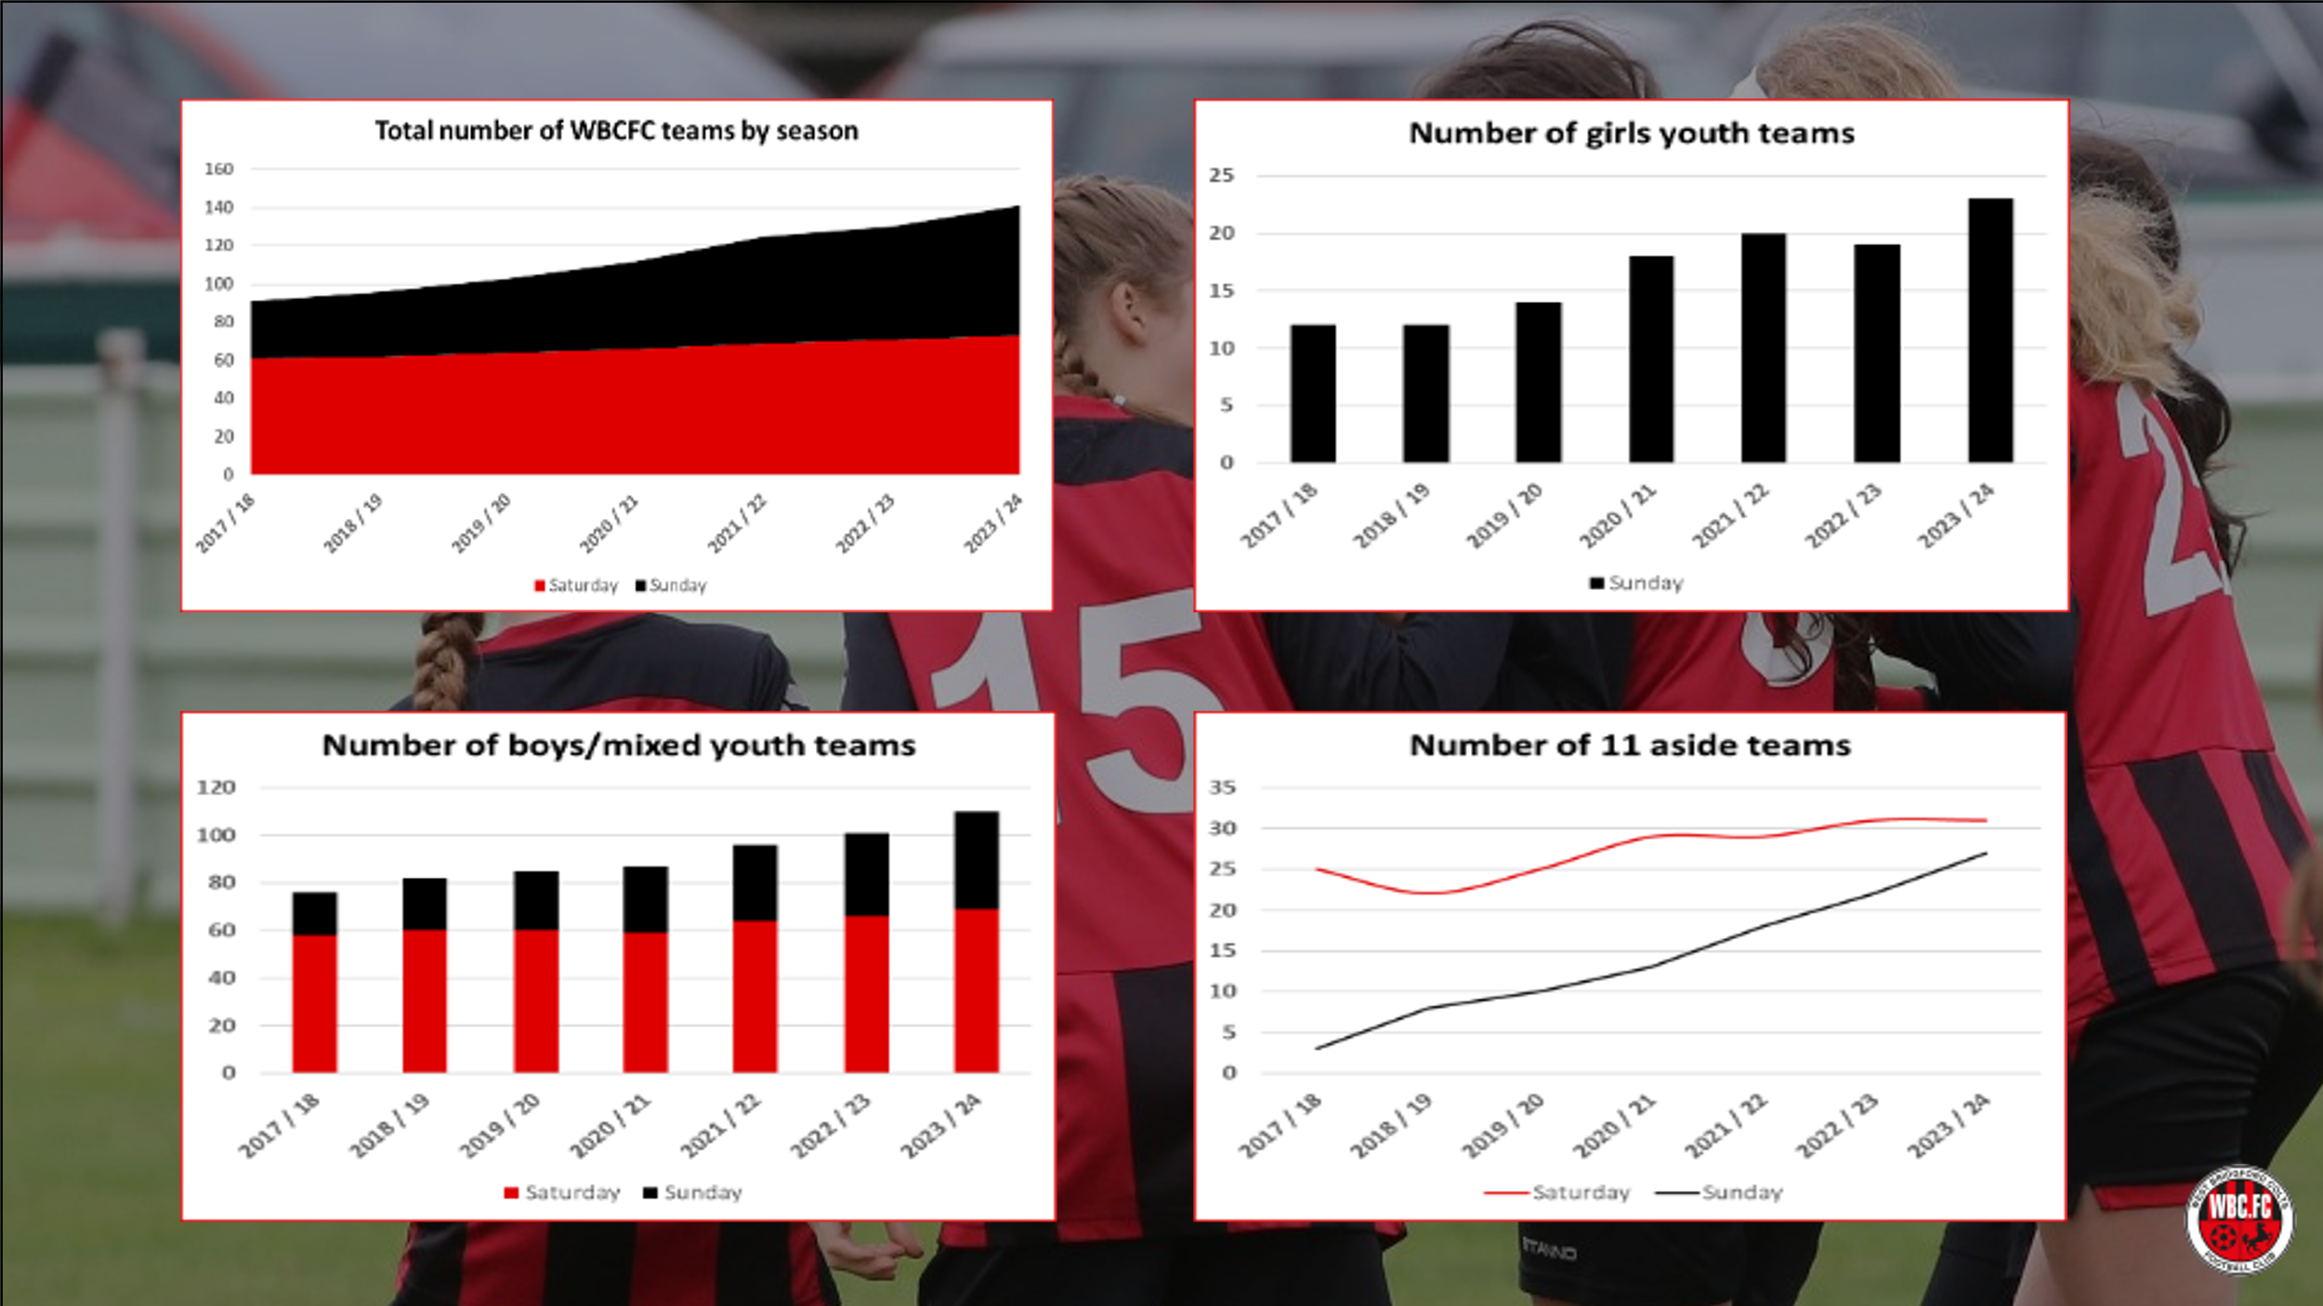

Grounds update
- We are still slowly progressing the 3G application and have finally submitted the initial legal documents. We have earmarked pitch 3 as the potential location.
- We are and have been working hard to secure new grass pitches, particularly 11 aside and have recently entered into an agreement to hire Emanuel School pitches.
- At the same time, we are exploring with the Council and other landowners’ opportunities to convert land to grass pitches.
- We will explore options for parking solution at Riverside.

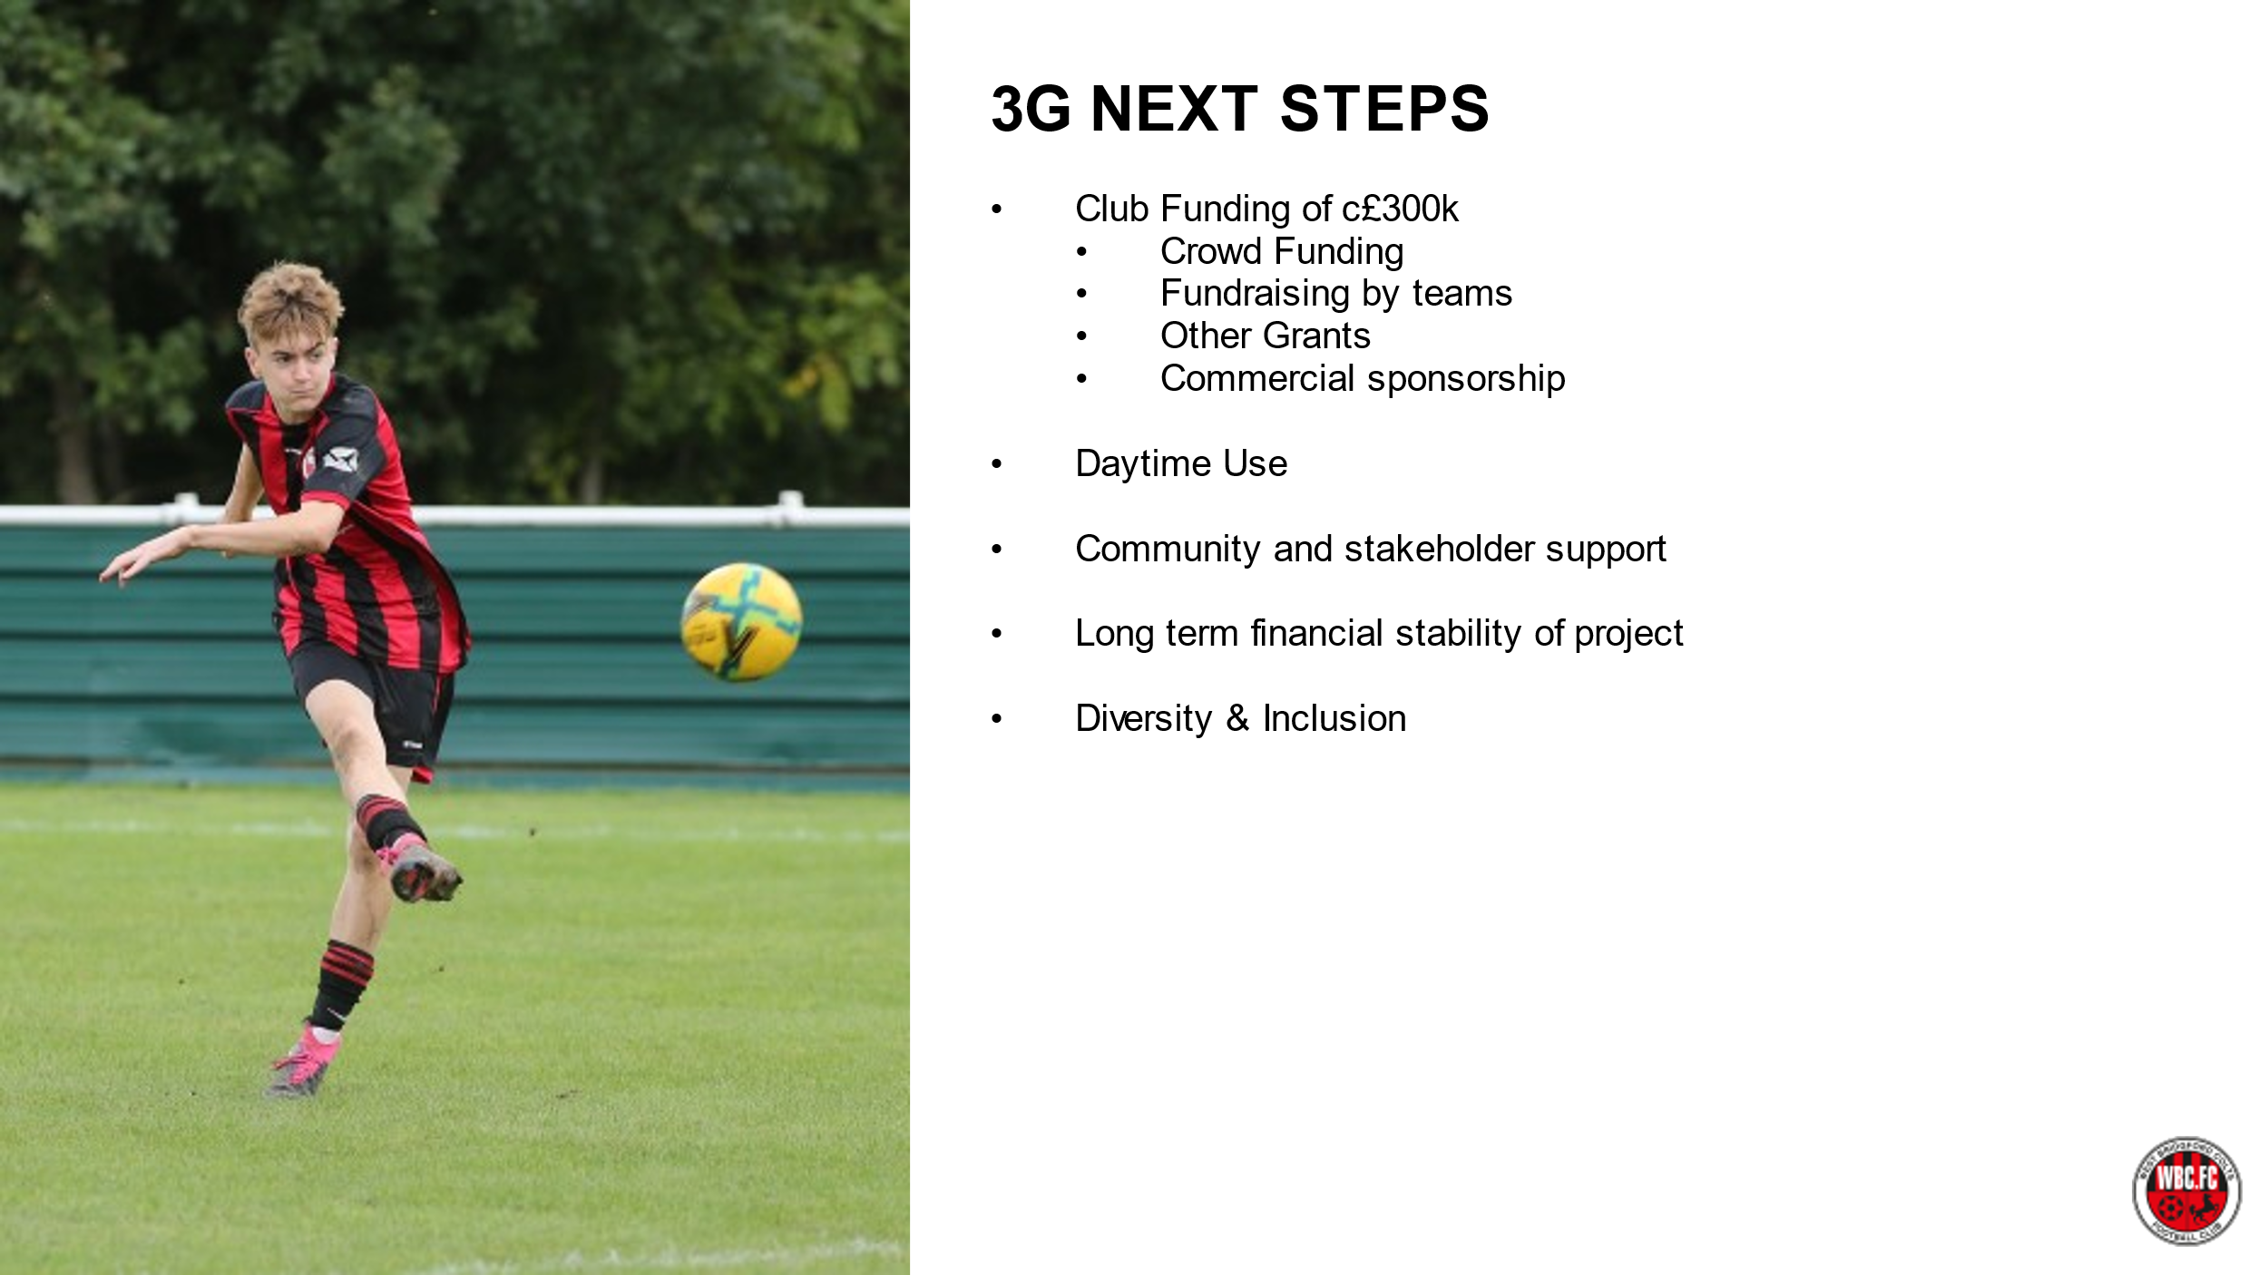

Recent initiatives
- We will be putting together a schedule for Coach Development for this season
- We will also be relaunching our club mascots scheme
- New head of Pan Disability & we plan to grow this section of the club
- Mini Colts is thriving and we are now almost full at U6
- Delighted to announce our club sponsor, The Campbell Clinic. Working with Colin Campbell, one of our coaches, we have agreed a lasting partnership which delivers not only sponsorship but also Marketing support – the team at TCC have revamped our website & manage our social media along with free use of their meeting facilities and discount for Colts players.
- We have also recently agreed an off-field partnership with Notts County Community Trust to jointly support local community activities and give our players and coaches the benefit of opportunities with the Club.
- We are also working on developing a partnership with Nottingham Forest

Turning to the future, our focus will be on 3 elements:
- Continue to run a professional and well organised Club that gives as many children and adults as possible the opportunity to play football in an inclusive and safe environment
- Apply to the Football Foundation for funding & secure the necessary additional funds to build a 3G pitch at Regatta Way by the end of 2025.
- Look at further options to secure more grass pitches.

If we deliver on these objectives, we will have 2000 children playing in 200 teams in 5 years’ time.

